Introduction to Compilers

A compiler is a program that reads a program written in one language (source language) and translates it into an equivalent program in another language (target language). The compiler reports errors present in the source program.
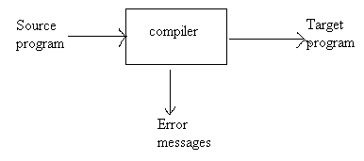
A Compiler
The target language may be another programming language or the machine language of a processor. Compilers are some times classified as single-pass, multi-pass, load-and-go, debugging, or optimizing, depending on how they have been constructed or on what function they are supposed to perform.

The Analysis-Synthesis Model of Compilation:

There are two parts to compilation
- Analysis
- Synthesis
The analysis part breaks up the source program into constituent pieces and creates an intermediate representation of the source program.
The synthesis part constructs the desired target program from the intermediate representation.
During analysis, the operations implemented by the source program are determined and recorded in a hierarchical structure called a tree. A special kind of tree called a syntax tree is used, in which each node represents operation and children of the node represent the arguments of the operation.

Eg: Syntax tree for position: =initial + rate * 60
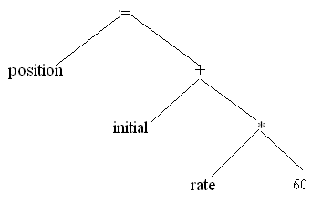

The Context of a Compiler:

In addition to a compiler several other programs may be required to create an executable target program. A source program may be divided in to modules stored in separate files. The task of collecting the source program is some times entrusted to a distinct program, called a preprocessors.
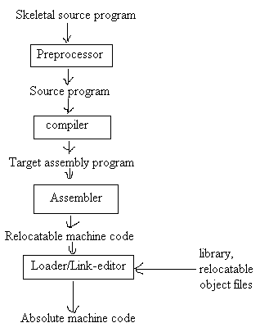
A language-processing system
The above figure shows a typical compiler. The target program created by the compiler may require further processing before it can be run. The compiler creates assembly code that is translated by an assembly into machine code and then linked together with some library routines into the code that actually runs on the machine.

Analysis of the Source program:

Analysis consists of three phases.
- Linear analysis – Divides the source program in to tokens.
- Hierarchical analysis – Generates parse tree to check syntax.
- Semantic analysis – The semantic analysis phase checks the source program for semantic errors.

Lexical Analysis:

In a compiler, linear analysis is called lexical analysis or scanning.
Eg: position: = initial + rate * 60
Would be grouped in to following tokens.
- The identifier position
- The assignment symbol :=
- The identifier initial
- The plus sign +
- The identifier rate
- The multiplication sign *
- The number 60

The blanks separating the characters of there tokens would normally be eliminated during lexical analysis.

Syntax Analysis:

Hierarchical analysis is called parsing or syntax analysis. It involves grouping the tokens of the source program into grammatical phases that are used by the compiler to synthesize output. The grammatical phrases of the source program are represented by a parse tree.
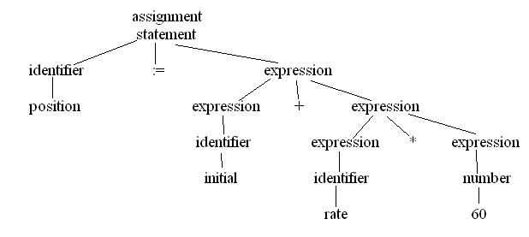
Semantic Analysis:

The semantic analysis phase checks the source program for semantic errors and gathers the information for the subsequent code generation phase.
An important component of semantic analysis is type checking. Here the compiler checks that each operator has operands that are permitted by the source language specification. For example, many programming languages definitions require a compiler to report an error every time a real number is used to index an array.

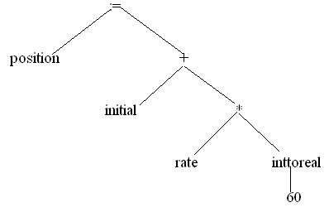
The Phases of a Compiler:
The compiler operates in phases, each of which transforms the source program from one representation to another. A typical decomposition of a compiler is shown in the below figure.
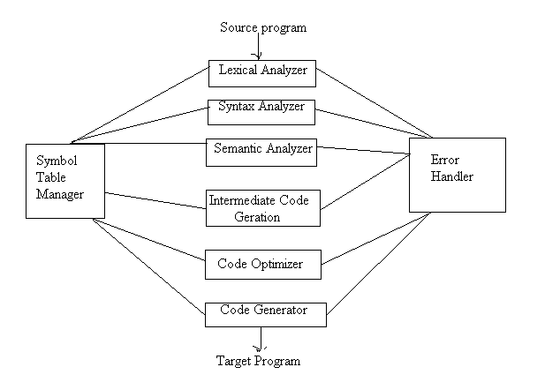

The compiler implementation process is divided into two parts.
- Analysis of source program
- Lexical analysis
- Syntax analysis
- Semantic analysis
- Synthesis of target program
  - Intermediate code generation
  - Code optimization
- Code generation
Analysis of the source program involves analyzing the different constructs of the program by breaking them into irreducible pieces and evaluating its syntax and semantics.
Synthesis of target program includes the process of representing source program in intermediate form and optimizing it to get improved machine code. It includes all machine independent phases of compiler.
Symbol Table Management:
An essential function of a compiler to record the identifiers used in the source program and collect information about various attributes of each identifier. These attributes may provide information about the storage allocation for an identifier, its type, its scope etc.
A symbol table is a data structure containing a record for each identifier, with fields for the attributes of the identifier. When an identifier in the source program is detected by the lexical analyzer, the identifier is entered in to the symbol table. However, the attribute of an identifier cannot normally be determined during lexical analysis. The remaining phases enter information about identifiers into the symbol table and then use this information in various ways.
Error Detection and reporting:
Each phase can encounter errors. However, after detecting an error, a phase must some how deal with that error, so that compiler can proceed, allowing further errors in the source program to be detected.
The syntax and semantic analysis phase usually handle a large fraction of the errors detectable by the compiler. The lexical phase can detect errors, where the characters remaining in the input do not form any token of the language.
Errors when the token stream violates the structure rules (syntax) of the language are determined by the syntax analysis phase. During semantic analysis the compiler tries to detect constructs that have the right syntactic structure but no meaning to the operation involved. E.g. if we add two identifiers, one of which is the name of an array and the other the name of a procedure.

The Analysis Phase:

- Lexical Analysis:
The lexical analysis phase reads the character in the source program and groups them into a stream of tokens in which each token represents a logically cohesive sequence of characters forming a token, such as an identifier, a keyword, a punctuation character, or a multi character operator like :=. The character sequence forming a token is called the lexeme for the token.
The lexical analysis, not only recognizes tokens but also the code value for that tokens. The value place contains a pointer to the symbol table where the actual value is stored.
E.g. position:= initial + rate * 60
Would be grouped in to the following tokens.
Position identifier
:= assignment
Initial identifier
+ plus sign
Rate identifier
‘*’ multiplication sign
60 constant.
- Syntax Analysis:
Syntax analysis involves grouping the tokens of the source program into grammatical phrases that are used by the compiler to synthesize output. Usually the grammatical phrases of the source program are represented by a parse tree.
- Semantic Analysis:
The semantic analysis phase checks the source program for semantic errors and gathers type information for the subsequent code generation phase.
- Intermediate Code Generation:
After syntax and semantic analysis, some compilers generate an explicit intermediate representation of the source program. We can think of this intermediate representation as a program for an abstract machine. This intermediate representation should have two important properties, it should be easy to produce, and easy to translate into the target program.
- Code Optimization:
The code optimization phase attempts to improve the intermediate code, so that faster running machine code will result.
Eg: temp: = id3 * 60.0
id1:= id2 +temp1
The compiler can deduce that the conversion of 60 from integer to real representation can be done once and for all at compile time, so the inttoreal operation can be eliminated.
- Code Generation:
The final phase of the compiler is the generation of target code, consisting normally of relocatable machine code or assembly code. Memory locations are selected for each of the variables used by the program. Then intermediate instructions are each translated into a sequence of machine instructions that perform the same task.
Example:

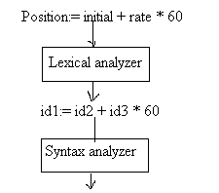
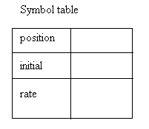

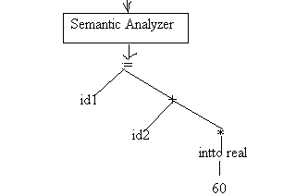

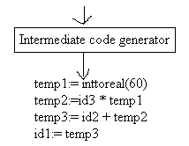
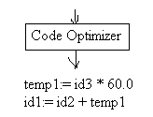
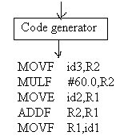

Language Processing:

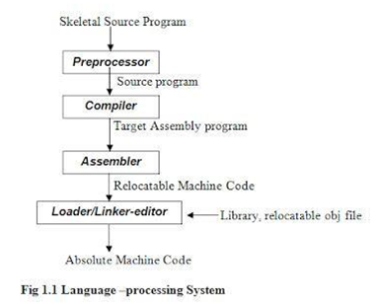
Cousins of the compiler:
Preprocessors:
A preprocessor produces input to compiler. They may perform the following functions.
- Macro processing: - A preprocessor may allow a user to define macros that are short hands fro longer constructs.
- File inclusion: - A preprocessor may include header files into the program text.
- Rational preprocessors: - These preprocessors expand older languages with more modern floe of control and data structuring facilities.
- Language extensions – These processors attempt to add capabilities to the language by what amount top built in macros.

Assemblers:
Some compilers produce assembly code that is passed to an assembler for further processing. Other compilers perform the job of the assembler, producing relocatable machine code that can be passed directly to the loader/link-editor.
Assembly code is a mnemonic version of machine code, in which names are used instead of binary codes for operations, and names are also given to memory address.
E.g.: MOV a, R1
ADD #2, R1
MOV R1, b
This code moves the contents of the address a into R1, then adds the constant 2 to it, and finally stores the result in the location named by b. thus it computes b: = a + 2.

Two pass Assembly:
The simplest form of assembler makes two passes over the input. In the first pass, all the identifiers that denote storage locations are found and stored in a symbol table. Identifiers are assigned storage locations as they encountered for the first time, so after reading, for example the symbol table might contain the entries shown in the figure below.
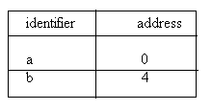
In the second pass, the assembler scans the input again. This time, it translates each operation code in to the sequence of bits representing that operation in machine language, and it translates each identifier representing a location into the address given for that identifier in the symbol table. The output of the second pass is usually relocatable machine code, i.e. it can be loaded starting at any location L in memory.

Loader and Link Editors:
Usually, a program called a loader performs the two functions of loading and link editing. The process of loading consists of taking relocatable machine code, altering the relocatable address and placing the altered instructions and data in memory at the proper locations.
The link editor allows us to make a single program from several files of relocatable machine code. These files may have been the result of several different compilations and one or more may be library files of routines provided by the system and available to any program that needs them.

The Grouping of Phases:
Front and Back Ends:
The phases are collected into a front end and a back end. The front end consists of those phases that depends primarily on the source language and are largely independent of the target machine. These normally include lexical and syntax analysis, the creation of symbol table, semantic analysis, and the generation of intermediate code. A certain amount of code optimization can be done by the front end as well as the front end also includes the error handling that goes along with each of these phases.
The back end includes those portions of the compiler that depend on the target machine, and generally these portions don’t depend on the source language, just the intermediate language. In the back end we find aspects of the code optimization phase, and we find code generation, along with the necessary error handling and symbol table operations.

Compiler construction tools:

- Parser Generators: - These produce syntax analyzer normally from input that is based on a context free grammar.
- Scanner Generators: - These automatically generate lexical analyzer, normally from a specification based on regular expressions.
- Syntax Directed translation engines: - These generates the intermediate code by traversing through parse tree.
- Automatic code Generators: - This converts intermediate code to assembly code of the target machine based on the architecture and instruction sets.
- Data flow Engines: - Much of the information needed to perform good code optimization involves “data flow analysis”, the gathering of information about how values are transmitted from one part of program to each other part.

The Evolution of Programming Languages:

1883: The Journey starts from here…!!
- In the early days, Charles Babbage had made the device, but he was confused about how to give instructions to the machine, and then Ada Lovelace wrote the instructions for the analytical engine.
- The device was made by Charles Babbage and the code was written by Ada Lovelace for computing Bernoulli’s number.
- First time in history that the capability of computer devices was judged.
1949: Assembly Language
- It is a type of low-level language.
- It mainly consists of instructions (kind of symbols) that only machines could understand.
- In today’s time also assembly language is used in real-time programs such as simulation flight navigation systems and medical equipment eg – Fly-by-wire (FBW) systems.
- It is also used to create computer viruses.
1952: Autocode
- Developed by Alick Glennie.
- The first compiled computer programming language.
- COBOL and FORTRAN are the languages referred to as Autocode.
1957: FORTRAN
- Developers are John Backus and IBM.
- It was designed for numeric computation and scientific computing.
- Software for NASA probes voyager-1 (space probe) and voyager-2 (space probe) was originally written in FORTRAN 5.
1958: ALGOL
- ALGOL stands for ALGOrithmic Language.
- The initial phase of the most popular programming languages of C, C++, and JAVA.
- It was also the first language implementing the nested function and has a simple syntax than FORTRAN.
- The first programming language to have a code block like “begin” that indicates that your program has started and “end” means you have ended your code.
1959: COBOL
- It stands for COmmon Business-Oriented Language.
- In 1997, 80% of the world’s business ran on Cobol.
- The US internal revenue service scrambled its path to COBOL-based IMF (individual master file) in order to pay the tens of millions of payments mandated by the coronavirus aid, relief, and economic security.
1964: BASIC
- It stands for beginners All-purpose symbolic instruction code.
- In 1991 Microsoft released Visual Basic, an updated version of Basic
- The first microcomputer version of Basic was co-written by Bill Gates, Paul Allen, and Monte Davidoff for their newly-formed company, Microsoft.
1972: C
- It is a general-purpose, procedural programming language and the most popular programming language till now.
- All the code that was previously written in assembly language gets replaced by the C language like operating system, kernel, and many other applications.
- It can be used in implementing an operating system, embedded system, and also on the website using the Common Gateway Interface (CGI).
- C is the mother of almost all higher-level programming languages like C#, D, Go, Java, JavaScript, Limbo, LPC, Perl, PHP, Python, and Unix’s C shell.

